FSD LAB REPORT
Full Stack Web Development - Practical Lab Assignments (1 to 6)
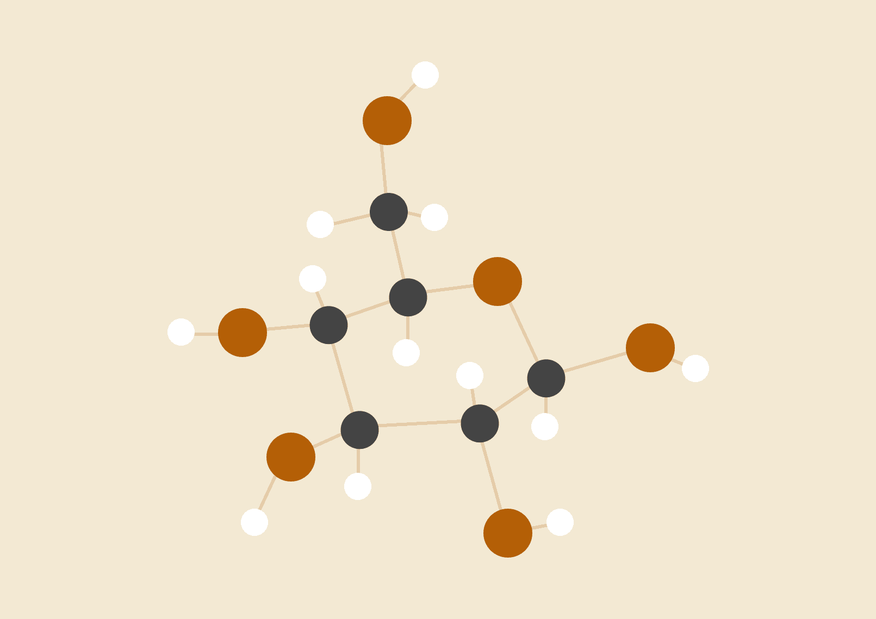
Rishabh Patil | PRN: 1272250228
Date: 26.10.2026
FULL STACK WEB DEVELOPMENT LAB

Assignment 1: JavaScript Calculator using Functions

Problem Statement & Objective
Create a calculator using JavaScript functions to perform basic arithmetic operations (addition, subtraction, multiplication, division). Use if-else or switch statements.

CODE
// --- Dedicated Arithmetic Functions ---
function add(num1, num2) {
return num1 + num2;
}
function subtract(num1, num2) {
return num1 - num2;
}
function multiply(num1, num2) {
return num1 * num2;
}
function divide(num1, num2) {
if (num2 === 0) {
return "Cannot divide by zero"; // Handling zero division
}
return num1 / num2;
}
// --- Main Calculator Controller Function ---
function performCalculation() {
var num1Input = document.getElementById('calc-num1').value;
var num2Input = document.getElementById('calc-num2').value;
var operator = document.getElementById('calc-operator').value;
var resultDisplay = document.getElementById('calc-result');
// Validation: Check for empty input fields
if (num1Input === "" || num2Input === "") {
resultDisplay.innerText = "Please enter both numbers!";
resultDisplay.style.color = "#e53e3e";
return;
}
var n1 = parseFloat(num1Input);
var n2 = parseFloat(num2Input);
var calculatedResult = 0;
// Switch statement to direct arithmetic operation
switch (operator) {
case "+":
calculatedResult = add(n1, n2);
break;
case "-":
calculatedResult = subtract(n1, n2);
break;
case "*":
calculatedResult = multiply(n1, n2);
break;
case "/":
calculatedResult = divide(n1, n2);
break;
default:
calculatedResult = "Invalid Operator";
}
resultDisplay.style.color = "#2b6cb0";
resultDisplay.innerText = "Result: " + calculatedResult;
}

GitHub Links
• Repo Link: https://github.com/GxdlRishabh07/FSD-Assignment
• Github Pages Link: https://gxdlrishabh07.github.io/FSD-Assignment/

Assignment 2: DOM-based To-Do List

Problem Statement & Objective
Build an interactive to-do list using HTML, CSS, and JavaScript. Use DOM methods to: (a) Add tasks, (b) Mark them as completed, and (c) Delete tasks dynamically.

CODE
function addTask() {
var inputField = document.getElementById('todo-input');
var taskText = inputField.value.trim();
if (taskText === "") {
alert("Please enter a task!");
return;
}
// Step 1: Create <li> node dynamically
var li = document.createElement('li');
li.className = 'todo-item';
// Step 2: Create task text node
var span = document.createElement('span');
span.className = 'todo-text';
span.innerText = taskText;
// Step 3: Create actions container
var actionsDiv = document.createElement('div');
actionsDiv.className = 'todo-actions';
// Step 4: Create 'Done/Toggle' action button
var doneBtn = document.createElement('button');
doneBtn.className = 'btn-action btn-toggle';
doneBtn.innerText = 'Done';
doneBtn.onclick = function() {
li.classList.toggle('completed'); // Toggle completion class
doneBtn.innerText = li.classList.contains('completed') ? 'Undo' : 'Done';
};
// Step 5: Create 'Delete' action button
var deleteBtn = document.createElement('button');
deleteBtn.className = 'btn-action btn-delete';
deleteBtn.innerText = 'Delete';
deleteBtn.onclick = function() {
li.remove(); // Dynamically remove node from DOM
};
// Step 6: Assemble element tree and append to unordered list
actionsDiv.appendChild(doneBtn);
actionsDiv.appendChild(deleteBtn);
li.appendChild(span);
li.appendChild(actionsDiv);
document.getElementById('todo-list').appendChild(li);
// Step 7: Clear input field for next entry
inputField.value = "";
}

GitHub Links
• Repo Link: https://github.com/GxdlRishabh07/FSD-Assignment
• Github Pages Link: https://gxdlrishabh07.github.io/FSD-Assignment/

Assignment 3: JavaScript Form Validation

Problem Statement & Objective
Create a user registration form with fields like name, email, phone, and password. Validate inputs using JavaScript and show appropriate error messages.

CODE
function validateRegistrationForm(event) {
event.preventDefault(); // Prevent default browser form submission
var nameInput = document.getElementById('reg-name');
var emailInput = document.getElementById('reg-email');
var phoneInput = document.getElementById('reg-phone');
var passwordInput = document.getElementById('reg-password');
var errorName = document.getElementById('error-name');
var errorEmail = document.getElementById('error-email');
var errorPhone = document.getElementById('error-phone');
var errorPassword = document.getElementById('error-password');
var successBox = document.getElementById('reg-success-message');
// Reset previous errors and highlights
errorName.innerText = "";
errorEmail.innerText = "";
errorPhone.innerText = "";
errorPassword.innerText = "";
nameInput.classList.remove('input-error');
emailInput.classList.remove('input-error');
phoneInput.classList.remove('input-error');
passwordInput.classList.remove('input-error');
successBox.style.display = "none";
var isValid = true;
// 1. Full Name Validation (minimum 3 characters)
var nameValue = nameInput.value.trim();
if (nameValue === "") {
errorName.innerText = "Full Name is required.";
nameInput.classList.add('input-error');
isValid = false;
} else if (nameValue.length < 3) {
errorName.innerText = "Name must be at least 3 characters long.";
nameInput.classList.add('input-error');
isValid = false;
}
// 2. Email Validation with RegEx
var emailValue = emailInput.value.trim();
var emailRegex = /^[^\s@]+@[^\s@]+\.[^\s@]+$/;
if (emailValue === "") {
errorEmail.innerText = "Email address is required.";
emailInput.classList.add('input-error');
isValid = false;
} else if (!emailRegex.test(emailValue)) {
errorEmail.innerText = "Please enter a valid email address.";
emailInput.classList.add('input-error');
isValid = false;
}
// 3. Phone Number Validation (exactly 10 digits)
var phoneValue = phoneInput.value.trim();
var phoneRegex = /^[0-9]{10}$/;
if (phoneValue === "") {
errorPhone.innerText = "Phone number is required.";
phoneInput.classList.add('input-error');
isValid = false;
} else if (!phoneRegex.test(phoneValue)) {
errorPhone.innerText = "Phone number must be exactly 10 digits.";
phoneInput.classList.add('input-error');
isValid = false;
}
// 4. Password Validation (min 6 characters)
var passwordValue = passwordInput.value;
if (passwordValue === "") {
errorPassword.innerText = "Password is required.";
passwordInput.classList.add('input-error');
isValid = false;
} else if (passwordValue.length < 6) {
errorPassword.innerText = "Password must be at least 6 characters long.";
passwordInput.classList.add('input-error');
isValid = false;
}
// Display confirmation on success
if (isValid) {
successBox.style.display = "block";
document.getElementById('registration-form').reset();
}
}

GitHub Links
• Repo Link: https://github.com/GxdlRishabh07/FSD-Assignment
• Github Pages Link: https://gxdlrishabh07.github.io/FSD-Assignment/

Assignment 4: React Profile Card using Props

Problem Statement & Objective
Set up a React app and create a component to display a user's profile card. Use props to pass name, image URL, and short description.

CODE
// --- Reusable ProfileCard Component Receiving Props ---
function ProfileCard(props) {
return (
<div className="profile-card">
{/* Image passed via prop */}
<img
src={props.imageUrl}
alt={props.name}
className="profile-avatar"
/>
{/* Name passed via prop */}
<h3 className="profile-name">{props.name}</h3>
{/* Role badge */}
<div className="profile-role">{props.role}</div>
{/* Description passed via prop */}
<p className="profile-desc">{props.description}</p>
</div>
);
}
// --- Parent Container Demonstrating Component Reusability ---
function ProfileCardApp() {
return (
<div className="cards-grid">
{/* Card Instance 1 */}
<ProfileCard
name="Rishabh Patil"
role="Frontend Developer"
imageUrl="https://images.unsplash.com/photo-1534528741775-53994a69daeb?w=200&auto=format&fit=crop&q=80"
description="Enthusiastic developer who loves creating clean UI designs, learning modern web technologies and building interactive web apps."
/>
{/* Card Instance 2 */}
<ProfileCard
name="Aditi Sharma"
role="React UI Designer"
imageUrl="https://images.unsplash.com/photo-1494790108377-be9c29b29330?w=200&auto=format&fit=crop&q=80"
description="Passionate about designing intuitive digital user interfaces, responsive layouts, and accessible component libraries."
/>
</div>
);
}
// Render component into DOM container
const root = ReactDOM.createRoot(document.getElementById('react-profile-card-root'));
root.render(<ProfileCardApp />);

GitHub Links
• Repo Link: https://github.com/GxdlRishabh07/FSD-Assignment
• Github Pages Link: https://gxdlrishabh07.github.io/FSD-Assignment/

Assignment 5: Controlled React Form

Problem Statement & Objective
Design a controlled form in React that accepts user inputs and displays the entered data in real-time below the form.

CODE
function ControlledFormApp() {
// 1. Single state object controlling all input fields
const [formData, setFormData] = React.useState({
fullName: '',
email: '',
techStack: 'React',
feedback: ''
});
// 2. Generic change handler to synchronize state with inputs
const handleChange = (e) => {
const { name, value } = e.target;
setFormData(prev => ({
...prev,
[name]: value
}));
};
return (
<div className="controlled-form-container">
<form onSubmit={(e) => e.preventDefault()}>
{/* Full Name Controlled Input */}
<div className="form-group">
<label>Full Name:</label>
<input
type="text"
name="fullName"
value={formData.fullName}
onChange={handleChange}
placeholder="Enter full name"
/>
</div>
{/* Email Controlled Input */}
<div className="form-group">
<label>Email Address:</label>
<input
type="email"
name="email"
value={formData.email}
onChange={handleChange}
placeholder="Enter email"
/>
</div>
{/* Controlled Select Dropdown */}
<div className="form-group">
<label>Favorite Tech Stack:</label>
<select name="techStack" value={formData.techStack} onChange={handleChange}>
<option value="React">React.js</option>
<option value="Node.js">Node.js</option>
<option value="JavaScript">Pure JavaScript</option>
<option value="Python">Python</option>
</select>
</div>
{/* Controlled Textarea */}
<div className="form-group">
<label>Bio / Notes:</label>
<textarea
name="feedback"
rows="3"
value={formData.feedback}
onChange={handleChange}
></textarea>
</div>
</form>
{/* Real-time live display of state */}
<div className="realtime-preview-box">
<h4>⚡ Real-Time Live Preview (Controlled by State):</h4>
<p><strong>Full Name:</strong> {formData.fullName || "(Waiting for input...)"}</p>
<p><strong>Email:</strong> {formData.email || "(Waiting for input...)"}</p>
<p><strong>Selected Tech:</strong> {formData.techStack}</p>
<p><strong>Bio:</strong> {formData.feedback || "(Waiting for input...)"}</p>
</div>
</div>
);
}
const root = ReactDOM.createRoot(document.getElementById('react-controlled-form-root'));
root.render(<ControlledFormApp />);

GitHub Links
• Repo Link: https://github.com/GxdlRishabh07/FSD-Assignment
• Github Pages Link: https://gxdlrishabh07.github.io/FSD-Assignment/

Assignment 6: React Counter App using useState

Problem Statement & Objective
Create a counter application in React with buttons to increment, decrement, and reset the value. Use React Hooks (useState).

CODE
function CounterApp() {
// 1. State variable: count and updater function: setCount
const [count, setCount] = React.useState(0);
// 2. Increment logic (+1)
const handleIncrement = () => {
setCount(prevCount => prevCount + 1);
};
// 3. Decrement logic (-1)
const handleDecrement = () => {
setCount(prevCount => prevCount - 1);
};
// 4. Reset logic (0)
const handleReset = () => {
setCount(0);
};
// 5. Dynamic color class calculation
let colorClass = "counter-zero";
if (count > 0) colorClass = "counter-positive";
else if (count < 0) colorClass = "counter-negative";
return (
<div className="counter-container">
<p>Current Value (Managed by <code>useState</code>):</p>
{/* Numerical Display */}
<div className={`counter-display ${colorClass}`}>
{count}
</div>
{/* Counter Control Buttons */}
<div className="counter-buttons">
<button className="counter-btn btn-decrement" onClick={handleDecrement}>
- Decrement
</button>
<button className="counter-btn btn-reset" onClick={handleReset}>
↺ Reset
</button>
<button className="counter-btn btn-increment" onClick={handleIncrement}>
+ Increment
</button>
</div>
</div>
);
}
const root = ReactDOM.createRoot(document.getElementById('react-counter-root'));
root.render(<CounterApp />);

GitHub Links
• Repo Link: https://github.com/GxdlRishabh07/FSD-Assignment
• Github Pages Link: https://gxdlrishabh07.github.io/FSD-Assignment/

